Banning Polyethylene Shopping Bags:

A Step Forward to Promoting Environmentally Sustainable Development in Bangladesh

Compiled by a Team led by Md. Reazuddin
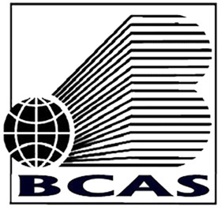
BANGLADESH CENTRE FOR ADVANCED STUDIES
House # 10, Road # 16A, Gulshan- 1, Dhaka- 1212, Bangladesh
Phone: (+880-2) 8851237, 8851986, 8852217; Fax: (880-2) 8851417
E-mail: info@bcas.net; Website: www.bcas.net

Table of Contents

Page No. | Topic | Page No.
1.0 | Background | 02
1.1 | Anti-polythene Campaign | 04
1.2 | Turning point : 1998 flood | 04
1.3 | The Study | 05
1.4 | Study findings | 05
2.0 | From Study to Action | 06
2.1 | Sensitization and Motivation | 07
2.2 | Ban in Dhaka City | 08
3.0 | Preparation for Nation Wide Ban | 10
3.1 | Nation Wide Ban | 11
3.2 | Waiver for some items | 12
4.0 | Overall Experience | 12
5.0 | Conclusion | 13

1.0 Background

It was World War II that placed plastics at the center of necessity. A rubber substitute called vinyl was used by Allied troops for waterproof tents and boots. An ultra-light insulation -polyethylene gave the British the ability to install radar on planes and ships and a critical advantage over the otherwise superior German Air Force and Navy. By 1979, plastic production surpassed that of steel, ushering in what Stephen Fenichell, author of Plastic: The Making of a Synthetic Century, calls the Plastic Age, a title as indicative of human progress as the Iron Age or the Bronze Age. Long-lasting super plastics are fast replacing metal in buildings, machines, and vehicles. The very endurance for which plastic was- celebrated, now haunts it. It is "the Rasputin of modern materials," says Fenichell. "You can break it, chop it, dice it, shred it, burn it, and bury it, but it stubbornly refuses to die." Eyen the plastics industry admits waste is a big problem, and a sub-industry of "green plastics" is trying to make plastics mortal. Polyethylene is a form of plastics. So management of post-consumer polyethylene shopping bags is a function of management of plastic wastes and an integral part of management of solid wastes.

It was only in the 1950s that plastics began to come into wide use in international arena, yet within few years, production has risen at an unparalleled rate. World consumption is now comparable with that of all non-ferrous metals.

Forecasts concerning the production of resins indicate that the economies of many developed and developing countries are increasingly relying on the use of plastics. In this regard the most intractable problem relating to plastics and the environment has been so far their disposal. Landfilling on one hand is increasingly seen to pose problems of environmental impact, because the availability of suitable sites is decreasing day by day. Moreover, the leaching of the plastic additives into the ground waters is now being questioned. On the other hand, uncontrolled burning of plastics including polyethylene in the dumping sites and other areas is not acceptable environment-wise. The controlled incineration of plastic waste is also raising concerns in some cases.

Polyethylene materials are not bio-degradable. Whenever a polyethylene bag is thrown away, it does not decompose through natural process. It contributes to the accumulation of non-destructive waste of permanent nature. If anybody looks at any garbage dumping site, he will observe this fact that although other garbage matter get decomposed and merged into the soil but polyethylene bags remain intact with their different colours especially the black coloured polyethylene bags. Polyethylene remains intact in the soil and disturbs the flow of nutrients to the soil and hinders entering sunlight. It destroys the beneficial bacteria of soil and losses soil fertility. It hinders the way of soil compaction, which in the long run effects the construction of foundation of the different structure.

The use of polyethylene is not environment friendly. Medical reports find it as an agent of cancer, skin diseases and other health problems. The users are more exposed to these types of health hazards when polyethylene is used to pack bread, biscuits, potato chips or other food items. In the developed countries, food is wrapped in food-graded plastic or polyethylene, but in Bangladesh this was not strictly followed and sometimes colorants are used, some of which may be carcinogenic.

Polyethylene industries for shopping bag production emerged in Bangladesh in early 80's and within a decade the industry reached in such a level that the jute bag production forced to be almost closed. The use of polyethylene shopping bags had been so enormous that one could find the polyethylene bags everywhere i.e in the street, dumpsites, drains, ditches, open-fields, roop tops, hanging from trees and overhead cables, floating on ponds, canals, rivers.

Survey report showed that near about 10 million polyethylene bags were used everyday and every year about 3000 million bags were dumped in Dhaka City alone. The steadily growing use of polyethylene bags posed an ominous environmental problem in the city as well as in rural areas. This enormous use of polyethylene bags led to - severe environmental impacts like soil degradation, loss of soil fertility, blocking up of drainage and sewerage systems, causing water logging and the spread of harmful microbes and bacteria. The worst example of adverse effect caused due to polyethylene bags was the delaying process of recession of flood water in Dhaka city during 1998.

One of the effective ways of management of polyethylene bags is recycling/reuse of post-consumer polyethylene bags for other useful purposes. But the state of recycling in Bangladesh again posed some other environmental hazards and some means of transmission of diseases. The burning of polythene in open air produces the threat of poisonous gas like carbon mono-oxide, carbon di-oxide hydrogen cyanide those causes health hazard to the people. The people who are involved in collection of polythene bags are the most vulnerable group.

1.1 Anti-polythene Campaign

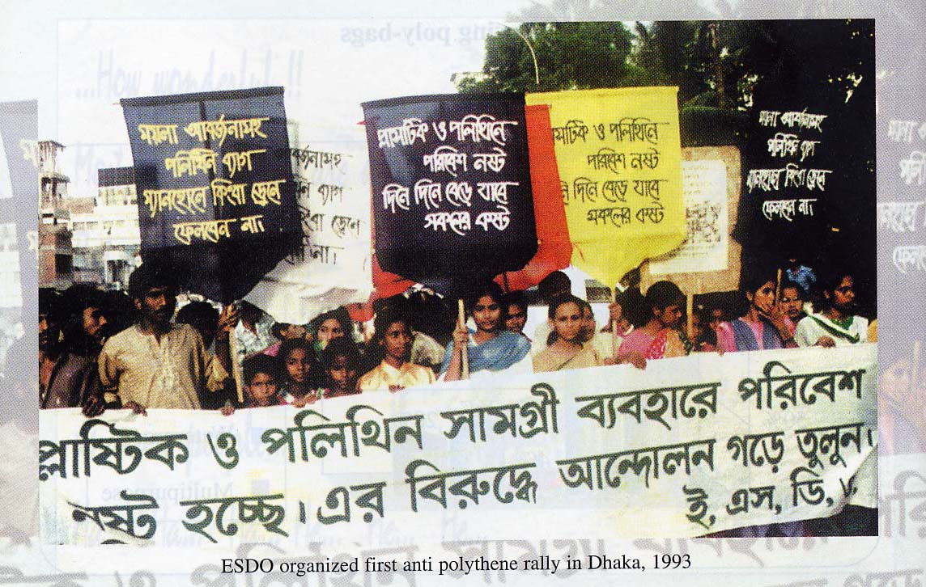
Environment and Social Development Organization (ESDO), an environmental NGO for the first time started campaign against polythene shopping bags in Bangladesh in 1992. It drew attention of the press as well as of the Government. A number of non-government organizations and public leader came forward to support the campaign. Some organizations demanded banning of production and use of polythene shopping bags. Based on the popular demand, in 1993, Ministry of Environment and Forest took an initiative to ban the production and trade of polythene bags outside Export Processing Zone (EPZ) with the approval of the cabinet, but it was not materialized. However, anti polyethylene campaign was picking up steadily and spreading from the capital city to other cities and towns.

1.2 Turning point : 1998 flood
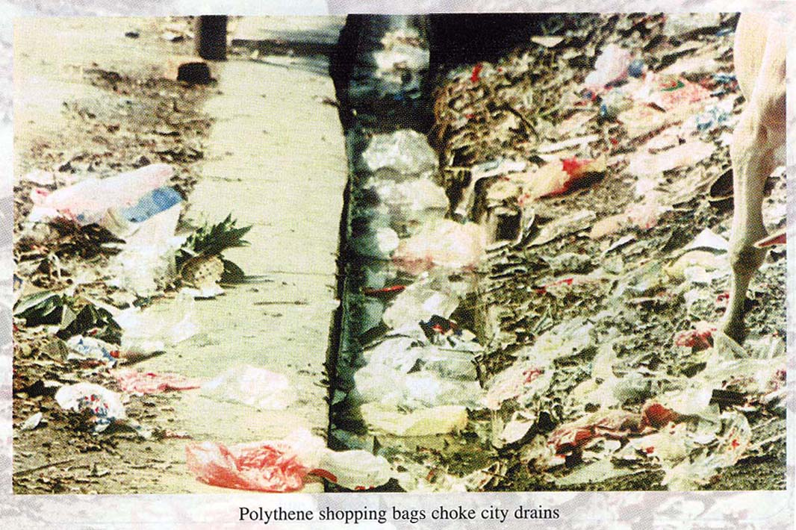
The campaign reached to its peak in the aftermath of 1998 flood, when two third areas of the country including a large part of the Dhaka City was under knee deep water for nearly two months. Clogging of city drains by polyethylene bags was the reason for delaying process of recession of flood water of Dhaka City. The people realized that indiscriminate use of polythene has been the root cause of their suffering owing to delay in the recession of flood water. In 1999, Ministry of Environment again started campaign against polyethylene through its Sustainable Environment Management Programme (SEMP), that led to the formation of a Task Force by the Government under the Ministry to work towards framing a Strategy for phasing out of polythene shopping bags. The Task Force recommended for undertaking a detailed study on the production, marketing and use of polythene shopping bags including on its socio-economic impacts before making the final decision.

1.3 The Study

The objective of the study has been to provide strategy to the Government :

- to establish a short-term programme for control and management of polyethylene and start for planning of its phasing out.
- to establish a mid-term programme for production of environmental friendly alternatives.
- to establish a long-term plan of action for the phasing out of the production of hazardous polyethylene bags
- to review the possibility of using the advanced and latest involved technology in the country.

1.4 Study findings

It was revealed that polythene bags used and dumped in Dhaka City was causing extreme health hazards like soil degradation, loss of agricultural land fertility, blocking up of the cities’ drainage and sewerage systems, water logging and the spread of harmful microbes and bacteria giving rise to epidemics. Other cities were also experiencing similar problems, but with lesser gravity. The country side was also experiencing polyethylene menace as people were no more using traditional bags made from jute or other sources.

The number of factories which produced polyethylene shopping bags, as perceived, widely varied from 800 to 1,700 by different categories of respondents/participants. In Bangladesh HDPE factories were started in 1982, but about 75 percent were established in the last decade, i.e. during 1990-2000. The total number of workforce employed in polyethylene factories of Bangladesh were estimated at 18,000 and another 7,000 workers are engaged in different stages of recycling. Thus, about 25,000 workers were related to polyethylene industry. The monthly average salary/wages of polyethylene workers ranges from Taka 2000-3200. On an average, work more than 8 hours a day. It appeared from the study that total number of polyethylene bags produced in the country had been 47 billion annually or 130 million per day for domestic and commercial use. Taking population at 129 million (The 2001 Population Census), per capita daily polyethylene production had been one bag. In terms of weight, only 20 percent of the total production was thinner and small the remaining 80 percent were thick and big bags. Therefore, if a decision on the ban of small and thinner category of polyethylene bag was taken, it would not seriously affect on the economy of the factories. Moreover, some of the loss could be compensated from the export of more bags to other countries with expanded government patronization and assistance. It was estimated that about 14.1 billion bags were used annually at household levels in Bangladesh. The annual total turn over of the polyethylene bag factories in Bangladesh would be Taka 6.78 billion.

The total amount of fixed capital invested in this sector had been estimated at about Tk. 2.25 billion including about Tk 750 million having invested by export-oriented firms. It can be mentioned here that previously garments packaging materials were imported from abroad. Now almost all these materials are produced in the country.

On analysis of alternatives and substitutes of polyethylene bags, jute bags, paper bags etc were suggested. The study observed that the alternate bags were costlier than the polyethylene shopping bags. Moreover polyethylene shopping bags were provided to for the purchasers free of cost. Some of the developed countries have partially adopted this new alternative giving up the idea of a total phase-out of the present non-biodegradable polyethylene bags, the study observed.

The study observed that existing legislation was not adequate to tackle the present situation. The study also observed that unless. Unless adequate policies are immediately adopted, its far-reaching affect will be too costly to be taken care of later. Requirement of new law to control, manage and supervise the production, import, export and usage of plastic and polyethylene bags in Bangladesh were considered necessary by the study.

The study further observed that creating public awareness on a given issue like Control and Management of Polyethylene Bags in Bangladesh was required to be high in the agenda.

The study finally recommended for a phase wise control on production and use of polyethylene shopping bags and identified thinner ones were more harmful. So, if any phase-out plan were to be made, thinner ones to go first.

2.0 From Study to Action

After a land slide victory in the Parliamentary Election in 2001, with a two third majority in the parliament, the Four Party Alliance Government under the leadership of Begum Khaleda Zia undertook a crash programme for 100 days. All the Ministries were asked to develop their own priority programmes for implementation within first 100 days of the government. Ministry of Environment and Forests prioritized anti polythene campaign as one of its priority programme and chalked out a detail plan that included preparation and dissemination of sensitization materials over polyethylene shopping bags depicting its adverse impacts and the alternatives to polythene shopping bags. Posters, leaflets were printed and distributed. Documentary and TV spots were made and broadcast. Processions and rallies were organized in the capital city as well as in other cities.

2.1 Sensitization and Motivation
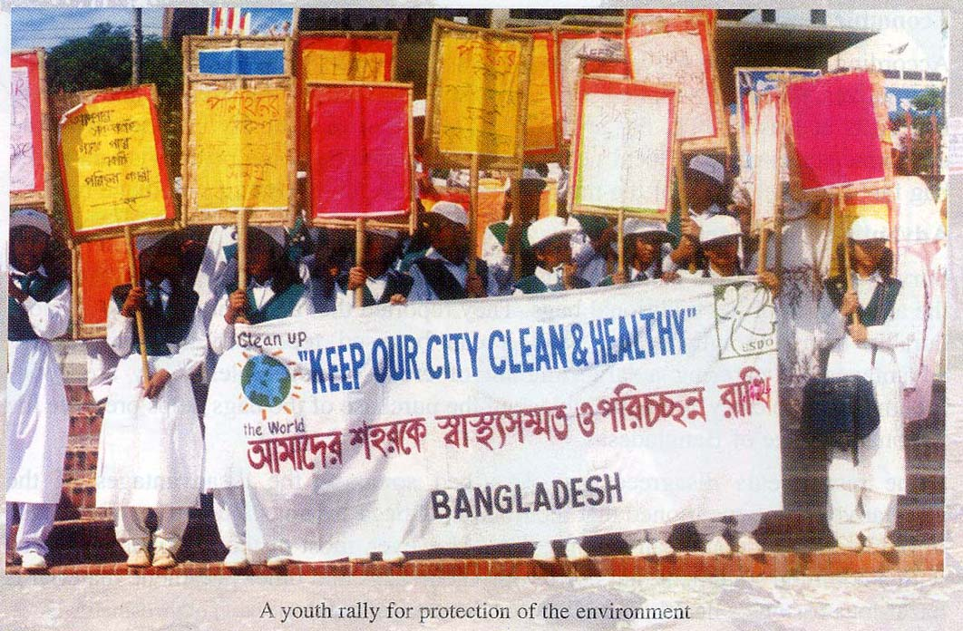
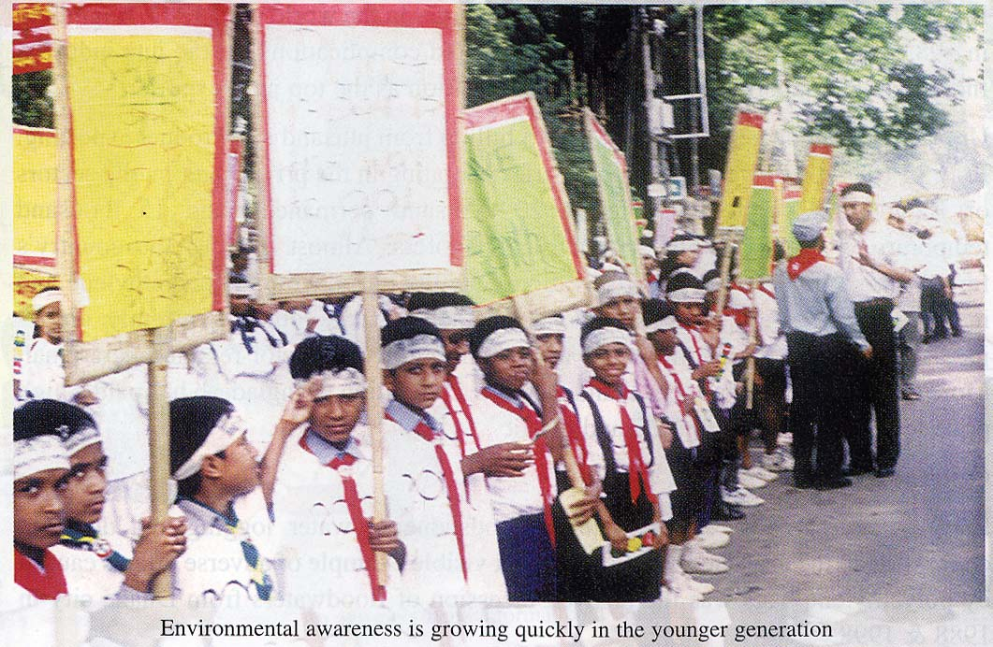
The campaign started with a policy level meeting involving all the stakeholders of polythene shopping bags including senior representatives from relevant Ministries, Importers of polythene raw materials and producers of shopping bags, producers of alternative bags, law enforcing agencies, representatives from various chambers, academics, NGO’s and the Press.

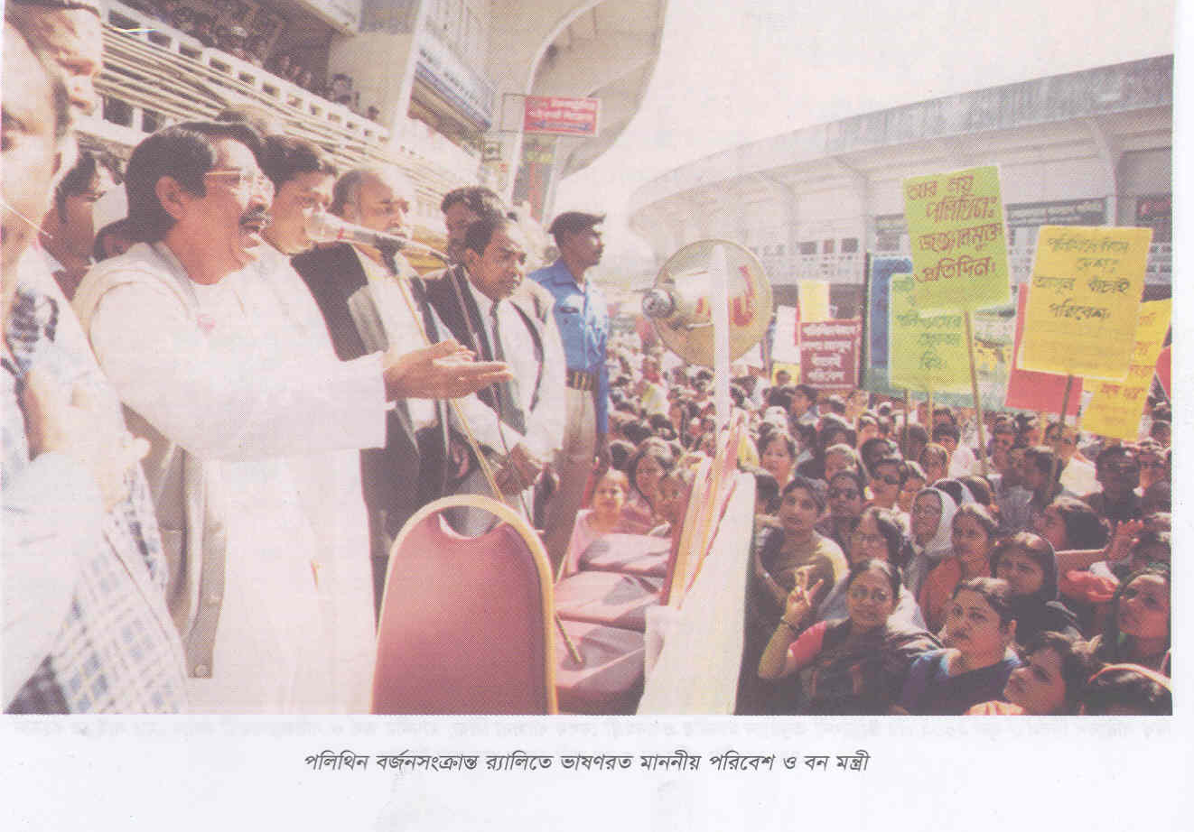
The people en-mass hailed the campaign and demanded for banning the production and use of polythene shopping bags specially the thinner ones, as thinner ones are recycled and create all the nuisance. The procession and rallies were spontaneously participated by people from all walks of life including students and housewives.

This was such a unique campaign that it was supported by opposition political parties as well. The Ministry under the leadership of the then Minister Mr. Shajahan Siraj was overwhelmed with support from all corners excepting a small trading group those who were engaged in the import of raw materials and as well as the marketing of various polyethylene materials. The overwhelmed support from the members of the public in general gave the Ministry a moral support to think for banning the use of thinner shopping bags in the initial phase.

The Ministry then held a series of meetings with the jute and paper bag producers including Bangladesh Jute Manufactures Exporters Association (BJMEA), Bangladesh Garments Manufacturers Exporters Association (BGMEA) and with different Chambers. The Ministry enquired from them whether they would be able to provide the alternative shopping bags to fill up the void, if the government arrived to a decision to ban the production and use of polyethylene shopping bags. All the associations, more importantly the BJMEA responded positively and promised that they would produce jute shopping bags to fill the gap and sell at a competitive price. The paper bags producers and the cloths bag producers also responded positively.

2.2 Ban in Dhaka City

With overwhelming support from user to manufacturers and exporters, the Ministry of Environment and Forests placed a proposal before the Cabinet to ban the production and use of polyethylene shopping bags in Dhaka city from January 1, 2002. The Cabinet agreed with the MOEF proposal.
The most widely circulated national newspaper while welcoming the government decision said:

“At long last, the ban on polybags seems firmly on course. The cabinet has okayed the environment ministry's proposal to prohibit use and marketing of thin polythene bags in Dhaka city from January 1, 2002. Something of a pleasant new year's gift in prospect! It is the 20 micron wafer-thin variety that is coming under the prohibitive orders. This is the scourge the market has been saturated with. As a non-biodegradable environmental hazard it has already wreaked havoc on public sanitation, not to speak of the irreparable damage its further use would inevitably bring to our life-system.

What we find hope-giving is that the government has after all weathered the initial lobby pressure to be able to announce the ban as an assertive signal that it means business down the road. BNP's earlier effort in 1994 and AL's subsequent initiative to ban polybags, both towards the end of their respective tenures in government, were predisposed to failure because of extremely limited lead-time they allowed themselves to bring it to any logical conclusion. We have always tried to carry the point with any new incumbency that hard decisions better be taken latest by the first year of the take-over.

There's no overstating, however, as to what the government has done at this stage. They have merely decided to prohibit the sale or use of polybags so that till such time as they have stopped the production of the same, the ban cannot truly take effect. Very importantly therefore, what remains to be done is crying a halt to the manufacture of polybags. Then we take the ban on sale and production of the item beyond Dhaka and major cities, well into the outlying areas of the country to cut all corners.

The most crucial input to the whole process ought to come from an assured supply of convenient and low-cost substitutes for polythene bags. There is an urgent need for rapid capacity building in terms of manufacturing and marketing paper bags, jute bags or carry-easy wrapping or container materials of all sorts.

Between the announcement of the ban and its implementation, the time-lag should be minimal; in fact these can be planned to go hand in hand so that the anti-ban lobbies don't feel resurrected to try and scuttle the noble undertaking.”

The BBC reports, “The government's decision to ban polythene was generally welcomed by the public, but environmental groups are doubtful how far the government will go to implement the decision.

The Environment Ministry has launched a massive publicity campaign to persuade the public not to use polyethylene bags.

The Environment Minister Mr. Shahajahan Siraj says the campaign has been successful in raising the awareness of the public about the hazards of the bags.

Mr. Siraj said that they were promoting jute bags as an alternative to polythene and people have responded positively. He said the government has decided to begin the process by banning use and manufacture of polythene bags. If necessary, laws would be amended for protecting the people from environmental hazards.

Regarding unemployment of people now working in polythene factories, he said steps will be taken to absorb them in jute and textile sectors.”

The Ministry then started a vigorous campaign from market to market for sensitization and motivation and announced that January 1, 2002 shall be the cut off date for production and use of 20 micron thick polyethylene shopping bags. The Ministry also kept close touch with the alternative producers and with BJMEA in particular. Then came the cut off date January 1, 2001. All the city markets got the supply of jute and other alternative paper and cloth bags. The BJMEA operated truck mounted mobile jute bag shopping centers all over the city of Dhaka. The success was unimaginable. The thinner polythene shopping bags, specially the black ones were not seen in the market and the people specially the housewives, purchased Jute bags instead of polyethylene bags. The government decision was hailed by the people from all walks of life.

It may be mentioned here that this campaign received overwhelming support from both print and electronic media.

3.0 Preparation for Nation Wide Ban

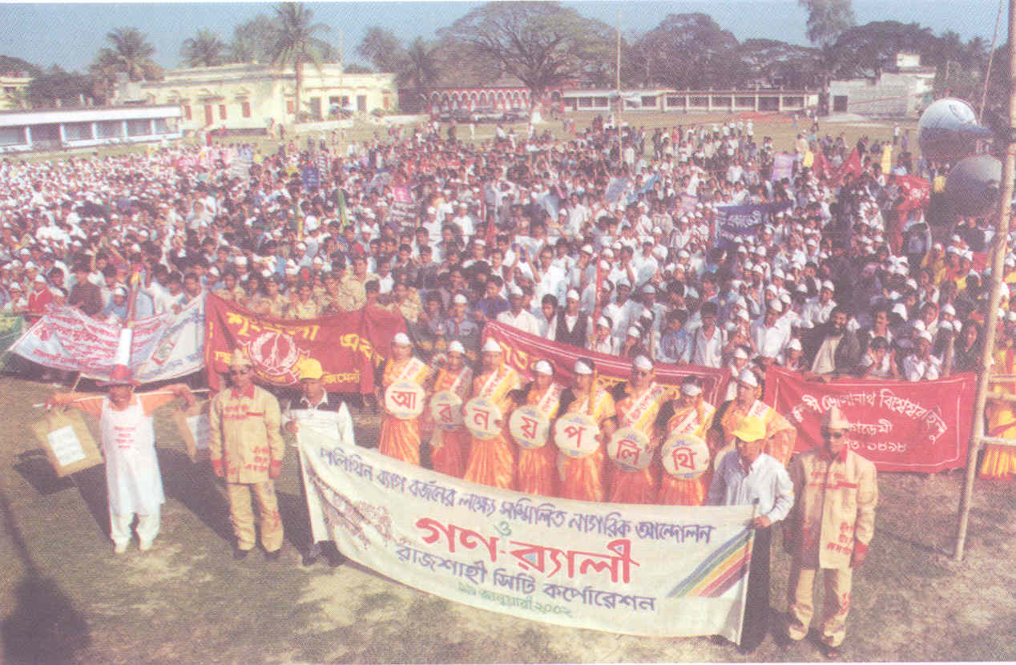
With the success in Dhaka city and popular support of the people, the Ministry of Environment and Forests chalked out an elaborate plan for nation-wide anti-polythene campaign. It produced a good number of TV spots and documentaries depicting adverse impacts of polythene in public life as well as in the environment. All the TV Channels telecast those spots and documentaries at free of cost. A number of leaflets and posters were published to carry out the campaign throughout the country. The Ministry organized rally and meetings in every district town where government officials, NGO representatives, political parties, academics, school children, boy scouts, girl guides and common mass participated in large numbers.

The debate in the capital started whether the government should go for all out ban of polythene shopping bags or only the thinner ones. The importers and traders tried to mobilize opinion in favour of banning only the thinner polythene upto 20 micron thickness but the people in general expressed their view for banning of all kind of polythene shopping bags. Some also expressed that it will be very difficult to distinguish between the 20 micron thickness bags with other bags. Measuring the thickness required sophisticated equipment. The Department of Environment bought a number of those equipment to enforce the Government ban of the polyethylene shopping bags. Some dishonest shopkeeper taking the advantage of the thickness issues started to bring back and sell their old stocks. Department of Environment with the help of Police and Local Market Association continued routine checking in the market, so that unscrupulous traders can not take the advantage of thickness issue. Department of Environment also organized mobile courts to punish the illegal traders and users. All these measures helped to wipeout thinner polyethylene bags from the market but there was always a problem of thickness issue between the enforcers and sellers.

Observing the all out support from all walks of life the Ministry put forward a proposal to the Cabinet for a nationwide ban on polyethylene shopping bags up to a thickness of 20 micron.

3.1 Nation Wide Ban

The cabinet discussed and saw an overwhening support of all the Cabinet Members for banning polythene shopping bags and decided to introduce ban on the production and use of all kinds of polythene shopping bags throughout the country with effect from March 01, 2002. The Government also decided to bring a bill in the parliament to this effect. This created a history of sorts in the parliamentary history where opposition members also lent their support to the bill. The bill was passed in the parliament without any opposition. This bill revised the Environment Conservation Act 95 with the insertion of 6 Ka which states :

"6A. Restrictions on manufacture, sale etc. of articles harmful to
environment.- If, on the advice of the Director General or otherwise, the Government is satisfied that all kinds or any kind of polythene shopping bag, or any other article made of polyethylene or polypropylene, or any other article is harmful to the environment, the Government may, by notification in the official Gazette, issue a direction imposing absolute ban on the manufacture, import, marketing, sale, demonstration for sale, stock, distribution, commercial carriage or commercial use, or allow the operation or management of such activities under conditions specified in the notification, and every person shall be bound to comply with such direction :

Provided that such direction shall not be applicable to the following cases :-
(a) if the article specified in the notification is exported or used
for export;
(b) if the direction mentions that it is not applicable to any
particular kind of polythene shopping bag.

Explanation. - In this section "polythene shopping bag" means a bag, thonga or other container which is made of polyethylene or poly propylene or any compound or mixture thereof and is used for purchasing, selling, keeping or carrying another article."

3.2 Waiver for some items

Thereafter, in consultation with different groups of traders and in consideration of the difficulties faced by them in marketing some food items and a few other item, which are hygroscopic and essential items related to life saving drugs, the Government with its authority by 6Ka of Environment Conservation Act 1995, declares “biscuit, chanachure, Aata, Moida (flour), Lacha Semai, Cha (Tea), Chocolate, Milk (solid and liquid), Naphthalene, fertilizer and Cement (only inner liners), and essential items in the drug manufacturing industries including disposal syringe are allowed to use polyethylene with 100 micron thickness in a gazette notification on 11.08.02 until the appropriate alternatives are available in the market. The notification also makes it very clear that the polythene materials which will be used for packaging the above mentioned materials shall not be allowed to use as polythene shopping bags.
4.0 Overall Experience

It has been observed that the alternative shopping bags made from jute, paper and clothes were costlier than the shopping bags made from polyethylene. The polythene shopping bags were much advantageous than its alternates especially in fish and vegetable market. On the contrary, survey indicated that groceries and departmental stores preferred jute and other alternative bags.

Taking the advantage of hidden demand in the fish and vegetable markets and taking the advantage of waiver for use of polythene as packaging materials for some products, some unscrupulous manufacturers and traders often try to produce and market polyethylene shopping bags without any lawful authority. However in general, the departmental stores, grocery markets are completely free from polyethylene shopping bags, only in fish and vegetable market one can find residual use of polyethylene shopping bags. They keep it hidden because of the fear of law enforcers.
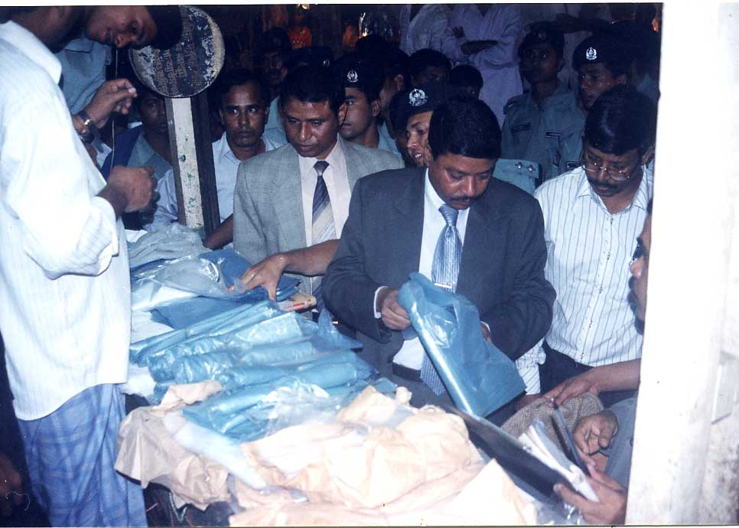

The Department of Environment organizes mobile courts to enforce the ban on regular basis with the help of the Metropolitan Magistracy and the Police. In many a times Hon’ble Minister and Hon’ble State Minister paid surprise visit to markets.

Drive against Polythene Shopping Bags.

The Government has formed a Taskforce headed by Director General of the Department of Environment with high level members from different law enforcing agencies including Police and BDR to oversee the enforcement of the law with regard to the polyethylene shopping bags. The Taskforce meet once a month and review the situation and coordinate the required enforcement programmes.

The Government for easy enforcement of the law, has extended its authority to the Police Department upto the rank of Sub-Inspector other than the officials of the Department of Environment to file cases against illegal traders of polythene and to take other necessary measures.

5.0 Conclusion

It can be said that, banning of polyethylene has achieved its success with a little residues left. People in general has accepted it. Now the city bins and garbage dumping sites are almost free from polythene shopping bags. They look much cleaner now. The city drains are no longer clogged with polyethylene shopping bags. Jute growers are particularly happy to see that demand for jute products in the domestic markets is going up. Polyethylene shopping bags manufacturers have now been engaged in the production of alternative bags and an additional huge number of jobs have been created in this sector.

The historic decision for banning polythene shopping bags not only ensured environmental benefits for the country it also created a great opportunity for generation of more employment and alleviating poverty in rural areas. The rejection of a non-biodegradable product by an entire nation is probably a unique example Bangladesh has set with peoples’ participation under a popular government. This pro-environment decision can be repeated in other arenas of nation building activities in other parts of the world to turn our only planet, the Earth, habitable for human beings.

